Spiral
# Source: AI Source: Provided by: [Data Path: Persons Table -> ID Column: 1, Name_En Column: Motasem Essam] -> From: [ChatGPT] on [7/25/2026]
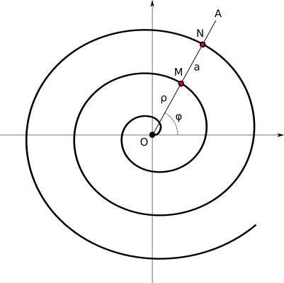
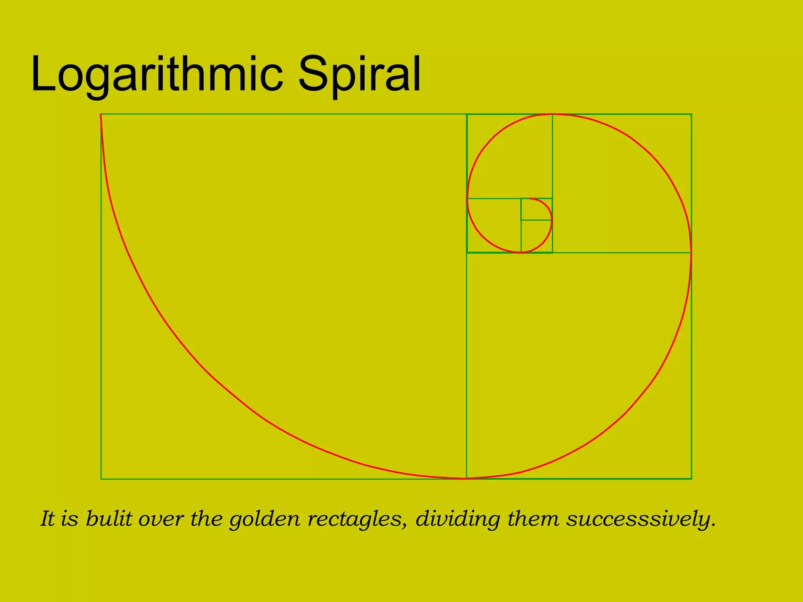
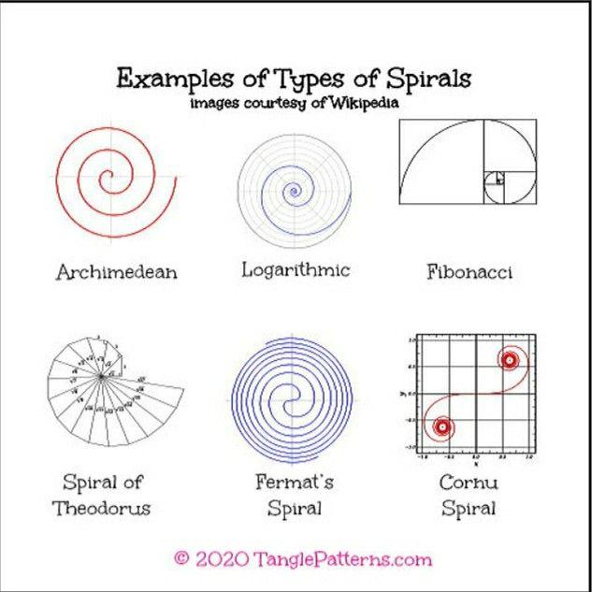
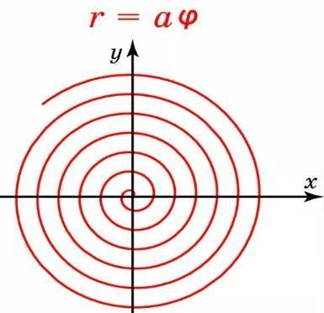
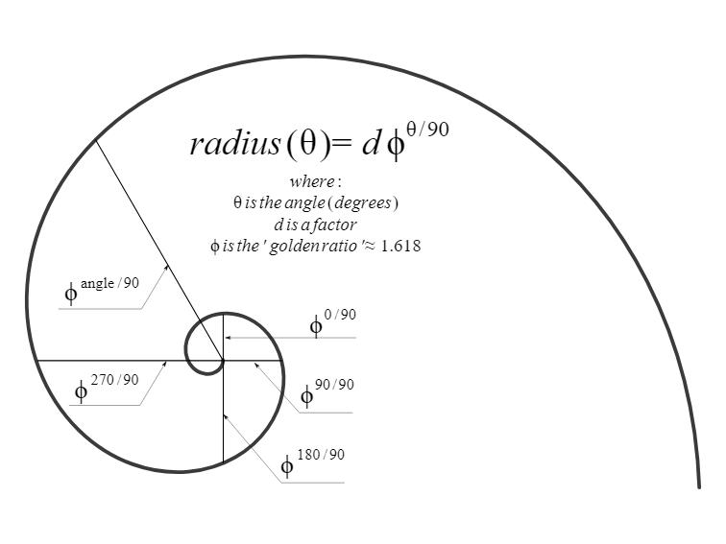
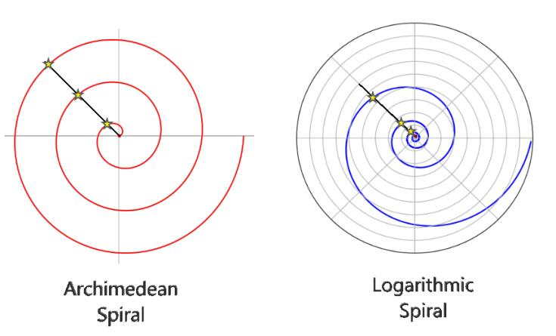
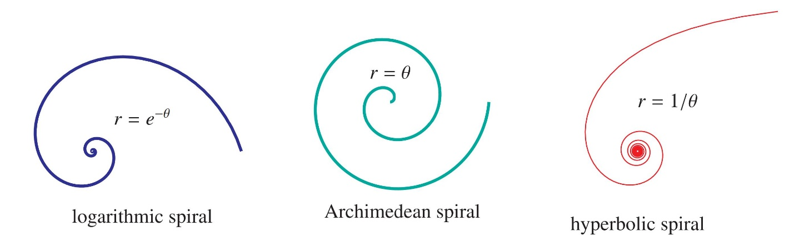

Definition
# Source: AI Source: Provided by: [Data Path: Persons Table -> ID Column: 1, Name_En Column: Motasem Essam] -> From: [ChatGPT] on [7/25/2026]
A Spiral is a curved geometric form that winds continuously around a central point or region while its distance from the center generally changes as it rotates.
A spiral can be described as a curve whose radial distance changes as its angular position changes.
Spiral = A curve that winds around a center while moving inward, outward, or both.
Unlike a circle, a spiral does not remain at a constant distance from its center.

Fundamental Concept
# Source: AI Source: Provided by: [Data Path: Persons Table -> ID Column: 1, Name_En Column: Motasem Essam] -> From: [ChatGPT] on [7/25/2026]
A spiral is commonly represented using polar coordinates:
$$\boxed{r=f\left(θ\right)}$$
where:
- $r$= distance from the center
- $θ$= angle from a reference direction
- $f\left(θ\right)$= rule describing how the radius changes
For a circle:
$$r=R$$
The radius remains constant.
For a spiral:
$$r=f\left(θ\right)$$
The radius generally changes as $θ$changes.
Therefore:
$$\boxed{\text{Circle: constant }r} \\ \boxed{\text{Spiral: changing }r}$$

Basic Structure
# Source: AI Source: Provided by: [Data Path: Persons Table -> ID Column: 1, Name_En Column: Motasem Essam] -> From: [ChatGPT] on [7/25/2026]
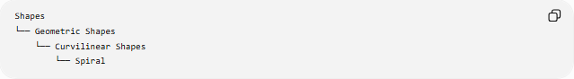
Shapes
└── Geometric Shapes
└── Curvilinear Shapes
└── Spiral
A spiral generally consists of:
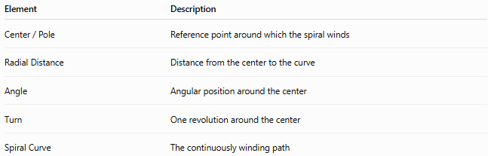
Element | Description
Center / Pole | Reference point around which the spiral winds
Radial Distance | Distance from the center to the curve
Angle | Angular position around the center
Turn | One revolution around the center
Spiral Curve | The continuously winding path
The center of a spiral is often called the pole in polar-coordinate descriptions.

Mathematical Representation
# Source: AI Source: Provided by: [Data Path: Persons Table -> ID Column: 1, Name_En Column: Motasem Essam] -> From: [ChatGPT] on [7/25/2026]
The general polar form of a spiral is:
$$\boxed{r=f\left(θ\right)}$$
For a point on the spiral:
$$P=\left(r , \cos{θ}r\sin{θ}\right)$$
Therefore, a parametric representation is:
$$\boxed{x=f\left(θ\right)\cos{θ}} \\ \boxed{y=f\left(θ\right)\sin{θ}}$$

Main Types of Spirals
# Source: AI Source: Provided by: [Data Path: Persons Table -> ID Column: 1, Name_En Column: Motasem Essam] -> From: [ChatGPT] on [7/25/2026]
Several important mathematical spiral families exist.

1-Archimedean Spiral
# Source: AI Source: Provided by: [Data Path: Persons Table -> ID Column: 1, Name_En Column: Motasem Essam] -> From: [ChatGPT] on [7/25/2026]
An Archimedean Spiral has a radius that changes linearly with the angle.
Its standard polar equation is:
$$\boxed{r=a+bθ}$$
where $a$and $b$are constants.
If $b>0$, the spiral moves outward as $θ$increases.
If $b<0$, it moves inward.
Important Property
The radial distance between successive turns is constant.
For one complete revolution:
$$Δθ=2π$$
The radial change is:
$$Δr=2πb$$
Therefore, the spacing between successive turns is constant.

2-Logarithmic Spiral
# Source: AI Source: Provided by: [Data Path: Persons Table -> ID Column: 1, Name_En Column: Motasem Essam] -> From: [ChatGPT] on [7/25/2026]
A Logarithmic Spiral has a radius that changes exponentially with the angle.
Its standard form is:
$$\boxed{r=ae^{bθ}}$$
where $a$and $b$are constants.
The radius therefore grows or decreases exponentially as the spiral rotates.
Important Property
The angle between the curve and radial lines remains constant.
This property is called equiangularity.

3-Hyperbolic Spiral
# Source: AI Source: Provided by: [Data Path: Persons Table -> ID Column: 1, Name_En Column: Motasem Essam] -> From: [ChatGPT] on [7/25/2026]
A Hyperbolic Spiral has an inverse relationship between radius and angle.
A common form is:
$$\boxed{r=\frac{a}{θ}}$$
where $a$is a constant.
As $θ$increases, $r$decreases.
Thus, the spiral approaches the center or another limiting behavior depending on the chosen domain.

4-Fermat's Spiral
# Source: AI Source: Provided by: [Data Path: Persons Table -> ID Column: 1, Name_En Column: Motasem Essam] -> From: [ChatGPT] on [7/25/2026]
A Fermat's Spiral has a radius proportional to the square root of the angle:
$$\boxed{r=a\sqrt{θ}}$$
where $a$is a constant.
Equivalently:
$$r^{2}=a^{2}θ$$
Its radial growth is slower than that of an Archimedean spiral.

5-Lituus
# Source: AI Source: Provided by: [Data Path: Persons Table -> ID Column: 1, Name_En Column: Motasem Essam] -> From: [ChatGPT] on [7/25/2026]
A Lituus is a spiral whose radius decreases according to the inverse square root of the angle.
A common equation is:
$$\boxed{r=\frac{a}{\sqrt{θ}}}$$
or equivalently:
$$\boxed{r^{2}=\frac{a^{2}}{θ}}$$
As $θ$increases, the spiral moves inward.

6-Golden Spiral
# Source: AI Source: Provided by: [Data Path: Persons Table -> ID Column: 1, Name_En Column: Motasem Essam] -> From: [ChatGPT] on [7/25/2026]
A Golden Spiral is a logarithmic spiral associated with the golden ratio:
$$\boxed{φ=\frac{1+\sqrt{5}}{2}}$$
A logarithmic representation can be written as:
$$\boxed{r=ae^{bθ}}$$
with a particular value of $b$chosen so that the radius grows by a factor of $φ$during a quarter turn.
A commonly used relationship is:
$$\boxed{b=\frac{\ln{φ}}{π/2}}$$
The golden spiral is therefore a particular type of logarithmic spiral.
The commonly drawn spiral inside a sequence of golden rectangles is an approximation to a mathematical golden logarithmic spiral, not an exact construction of the curve.

Spiral Classification
# Source: AI Source: Provided by: [Data Path: Persons Table -> ID Column: 1, Name_En Column: Motasem Essam] -> From: [ChatGPT] on [7/25/2026]
A useful mathematical classification is:
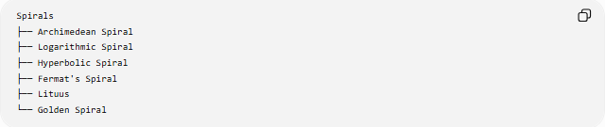
Spirals
├── Archimedean Spiral
├── Logarithmic Spiral
├── Hyperbolic Spiral
├── Fermat's Spiral
├── Lituus
└── Golden Spiral
These are mathematical families distinguished primarily by how $r$changes with $θ$.

Open Nature of a Spiral
# Source: AI Source: Provided by: [Data Path: Persons Table -> ID Column: 1, Name_En Column: Motasem Essam] -> From: [ChatGPT] on [7/25/2026]
A spiral is generally an open curve rather than a closed curve.
It does not normally return to its starting point after one revolution.
For example:
$$r=a+bθ$$
gives a different radius after every additional $2π$radians.
Thus:
$$r\left(θ+2π\right)≠r\left(θ\right)$$
in general.
This distinguishes a spiral from a circle.

Number of Turns
# Source: AI Source: Provided by: [Data Path: Persons Table -> ID Column: 1, Name_En Column: Motasem Essam] -> From: [ChatGPT] on [7/25/2026]
The number of turns made by a spiral over an angular interval is:
$$\boxed{N=\frac{Δθ}{2π}}$$
For example, if
$$Δθ=6π$$
then:
$$N=\frac{6π}{2π}=3$$
So the curve makes 3 complete turns.

Spiral Direction
# Source: AI Source: Provided by: [Data Path: Persons Table -> ID Column: 1, Name_En Column: Motasem Essam] -> From: [ChatGPT] on [7/25/2026]
A spiral can move:
Outward
The radial distance increases:
$$\boxed{\frac{dr}{dθ}>0}$$
Inward
The radial distance decreases:
$$\boxed{\frac{dr}{dθ}<0}$$
Variable
The radial distance can alternately increase and decrease:
$$\boxed{\frac{dr}{dθ}}$$
changes sign over different intervals.

Spiral Spacing
# Source: AI Source: Provided by: [Data Path: Persons Table -> ID Column: 1, Name_En Column: Motasem Essam] -> From: [ChatGPT] on [7/25/2026]
The distance between successive turns depends on the type of spiral.
Archimedean Spiral
The radial spacing between turns is constant:
$$\boxed{Δr=2πb}$$
Logarithmic Spiral
The radial spacing is not constant.
The radius is multiplied by a constant factor after each fixed angular increment.
Thus, successive turns become progressively larger or smaller depending on the sign of $b$.

Arc Length
# Source: AI Source: Provided by: [Data Path: Persons Table -> ID Column: 1, Name_En Column: Motasem Essam] -> From: [ChatGPT] on [7/25/2026]
For a polar curve
$$r=f\left(θ\right)$$
the arc length between $θ_{1}$and $θ_{2}$is:
$$\boxed{L=\int_{θ_{1}}^{θ_{2}}{\sqrt{r^{2}+{\left(\frac{dr}{dθ}\right)}^{2}}} dθ}$$
This general formula can be applied to many spiral types.

Area Swept by a Spiral
# Source: AI Source: Provided by: [Data Path: Persons Table -> ID Column: 1, Name_En Column: Motasem Essam] -> From: [ChatGPT] on [7/25/2026]
The area swept between two angular positions is:
$$\boxed{A=\frac{1}{2}\int_{θ_{1}}^{θ_{2}}{r^{2}} dθ}$$
For example, if the spiral is:
$$r=a+bθ$$
then:
$$A=\frac{1}{2}\int_{θ_{1}}^{θ_{2}}{(}\left.a+bθ{\left.)\right.}^{2} dθ\right.$$

Spiral vs Circle
# Source: AI Source: Provided by: [Data Path: Persons Table -> ID Column: 1, Name_En Column: Motasem Essam] -> From: [ChatGPT] on [7/25/2026]
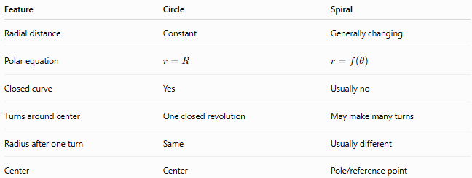
Feature | Circle | Spiral
Radial distance | Constant | Generally changing
Polar equation | $$r=R$$ | $$r=f\left(θ\right)$$
Closed curve | Yes | Usually no
Turns around center | One closed revolution | May make many turns
Radius after one turn | Same | Usually different
Center | Center | Pole/reference point
The key difference is:
$$\boxed{\text{Circle: }r=\text{constant}} \\ \boxed{\text{Spiral: }r\text{ changes with }θ}$$

Spiral vs Concentric Circles
# Source: AI Source: Provided by: [Data Path: Persons Table -> ID Column: 1, Name_En Column: Motasem Essam] -> From: [ChatGPT] on [7/25/2026]
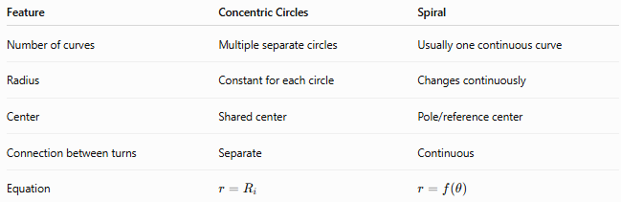
Feature | Concentric Circles | Spiral
Number of curves | Multiple separate circles | Usually one continuous curve
Radius | Constant for each circle | Changes continuously
Center | Shared center | Pole/reference center
Connection between turns | Separate | Continuous
Equation | $$r=R_{i}$$ | $$r=f\left(θ\right)$$
A spiral can look similar to concentric circles at some points, but its turns are connected continuously.

Example
# Source: AI Source: Provided by: [Data Path: Persons Table -> ID Column: 1, Name_En Column: Motasem Essam] -> From: [ChatGPT] on [7/25/2026]
Consider the Archimedean spiral:
$$\boxed{r=2+θ}$$
At
$$θ=0$$
we have:
$$r=2$$
After one complete revolution:
$$θ=2π$$
so:
$$r=2+2π$$
Therefore, the radial increase after one complete turn is:
$$\boxed{2π}$$
The spiral moves outward continuously.

Symmetry
# Source: AI Source: Provided by: [Data Path: Persons Table -> ID Column: 1, Name_En Column: Motasem Essam] -> From: [ChatGPT] on [7/25/2026]
Spirals may or may not have symmetry depending on their equation.
For example, a standard Archimedean spiral can have rotational relationships between successive turns, but it generally does not have the same full rotational symmetry as a circle.
Some specially constructed spirals can have reflection or rotational symmetry.
Therefore:
Spiral is a curve type, not a symmetry classification.
A spiral can be symmetric or asymmetric depending on its mathematical construction.

Key Points
# Source: AI Source: Provided by: [Data Path: Persons Table -> ID Column: 1, Name_En Column: Motasem Essam] -> From: [ChatGPT] on [7/25/2026]
- A Spiral is a curve that winds around a central point while its radial distance changes.
- Its general polar representation is:
$$\boxed{r=f\left(θ\right)}$$
- A point on the spiral can be written as:
$$\boxed{\left(r , \cos{θ}r\sin{θ}\right)}$$
- A spiral is generally an open curve.
- It can wind inward or outward.
- The number of turns is:
$$\boxed{N=\frac{Δθ}{2π}}$$
- Important mathematical types include:
  - Archimedean Spiral
  - Logarithmic Spiral
  - Hyperbolic Spiral
  - Fermat's Spiral
  - Lituus
  - Golden Spiral
- The Archimedean Spiral has constant radial spacing between turns.
- The Logarithmic Spiral grows or decreases exponentially.
- The Golden Spiral is a particular logarithmic spiral associated with the golden ratio.

Conclusion
# Source: AI Source: Provided by: [Data Path: Persons Table -> ID Column: 1, Name_En Column: Motasem Essam] -> From: [ChatGPT] on [7/25/2026]
A Spiral is a curvilinear geometric form that continuously winds around a central point while its distance from that point changes with the angle. Its general mathematical representation is
$$\boxed{r=f\left(θ\right)}$$
which makes polar coordinates particularly suitable for describing spirals. Different relationships between $r$and $θ$produce different spiral families, such as the Archimedean, logarithmic, hyperbolic, Fermat, Lituus, and golden spirals. The defining idea is that, unlike a circle whose radius remains constant, a spiral changes its radial distance as it rotates around its center.

